|  |  |
| --- | --- |
| **Test Name** | Crown & Anchor Automated Test for Fix of Bug 1 |
| **Use Case Tested:** | Automate the testing of errors in UAT Test 1 (for fix of Bug 1) |
| **Test Description:** | Test that player’s balance does not increase when one match with the rolled dice occurs |
| **Pre-conditions** | Single player ‘Sally’ created  Each run to use a single dice value ‘CROWN’ as the player’s pick  Game will roll dice until 10 single matches are found  Balance set at $30 |
| **Post-conditions** | n/a |
| **Notes:** | **An assert will determine if player’s balance has been increased in any of the single dice roll matches**  **Note this also tests the result of the player’s balance if two or more matches are occurring.**  **This test also shows Bug 4, which is that each roll in the same game produces the same three dice rolls.** |
| **Result (Pass/Fail/Warning/Incomplete)** | **1) When the game rolls three different dice and the player’s dice matches one of them, the balance does change (it increments by the value of the bet) – see screenshot 1.**  **2) When the game rolls two of three of the same dice and the player’s die role matches them, the balance does change (it increments by the value of the bet times the number of matches) – see Screeenshot 2. However, note this particular test runs in endless loop due to the nature of the selection of a matching die in the test program – although it still demonstrates the incrementing of the balance.**  **3) When the player’s die does not match any of the game’s dice, the balance does change (it decrements by the value of the bet) – see Screenshot 3.** |

# Screenshots

Screenshot 1:

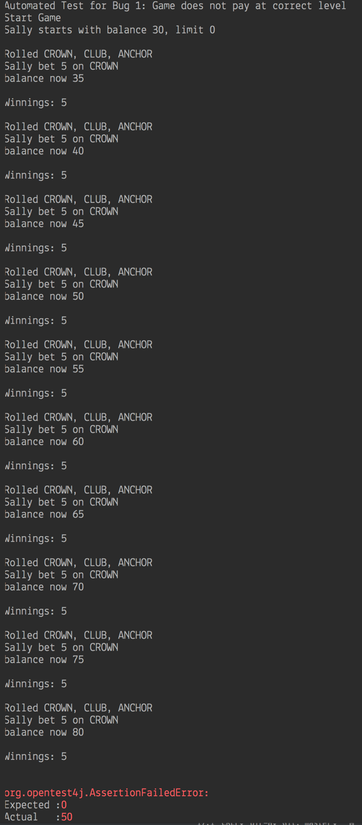

Screenshot 2:

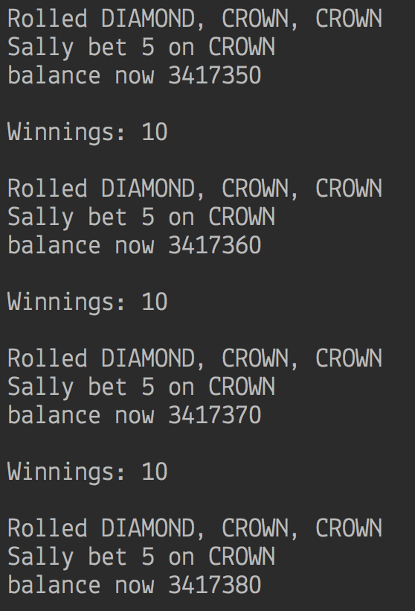

Screenshot 3:

